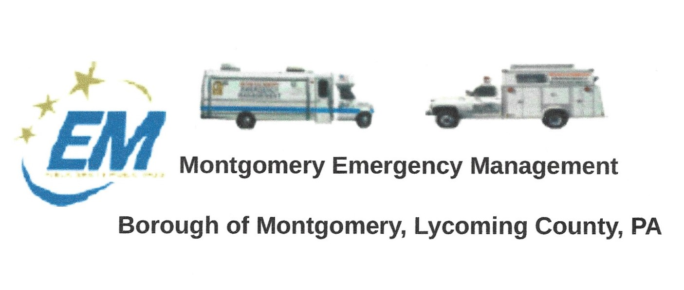
The next regular monthly meeting of the Montgomery Borough Emergency Management Agency will be:
Greg Gruver, EMA Coordinator. 77 East Houston Avenue, Montgomery, PA 17752
Telephone: 570-547-1212 Cell: 570-419-4866 Email: montema631@gmail.com
Fae Herb, Administrative Assistant. 102 Broad Street, Montgomery, PA 17752
Cell: 570-506-9892. Email: faeherb@aol.com
Meeting Room and Equipment Building: 40 Thomas Avenue
Borough EOC: 570-547-1671. Fire Hall EOC: 570-547-1380
INTERNET WEBSITE: www.montgomeryboroughema.org

THURSDAY MAY 12, 2022
Never second-guess Punxsutawney Phil, as he predicted on February 2, 2022 that we would have six more weeks of winter. Beautiful weather teased us in April when suddenly a nor’easter brought snow, no doubt a late April Fools joke from Phil. But sunshine and warm temperatures came back. Montgomery EMA personnel was prepared as all their equipment was ready to be used in case of an emergency.
The EMA recently was donated a 2013 inflatable boat, in excellent condition. The motor from our other boat has been serviced and ready to go. Once title is transferred, the boat will go to have stenciling done. Let’s hope that history does not repeat itself as the anniversary of Agnes is approaching in June.
Several local events have been planned for the Community and help is always needed to make them a success. Easter Egg Hunt, Lions 5K Walk & Run, Black Hole Clean Up Day, Fishing Derby, Memorial Day service and July Fireworks on Sunday, July 3rd.
Help is needed in maintaining the grounds around the EMA building. Picking up sticks and mowing the grass. Matt Okkelberg has a mower that will be used for that purpose.
MAY REFRESHEMENT WILL BE SUPPLIED BY DALE BRENDLE
MEMBERS ARE REMINDED OF TUESDAY WEEKLY RADIO CHECK AT 6 P.M.

Submitted by: Fae Herb – Administrative Assistant

